Aim: Perform FFT and IFFT on discrete time signal
Theory :-
Fast Fourier Transform (FFT) is an efficient technique used to convert a discrete-time signal from the time domain into the frequency domain. It helps to identify the different frequency components present in a signal. The magnitude spectrum shows the strength of these frequency components, while the phase spectrum provides their phase information. Inverse Fast Fourier Transform (IFFT) is used to convert the frequency-domain signal back into the time domain. The reconstructed signal obtained using IFFT should be approximately the same as the original signal. In Python, np.fft.fft() is used to perform FFT and np.fft.ifft() is used to perform IFFT. FFT and IFFT are widely used in digital signal processing, audio processing, communication systems, and frequency analysis.

Code:-
import numpy as np
import matplotlib.pyplot as plt
signal = np.array([1, 2, 3, 4, 5, 6, 7, 8])
# Compute the FFT of the signal
fft_result = np.fft.fft(signal)
# Compute the magnitude and Phase spectrum of the FFT result
magnitude_spectrum = np.abs(fft_result)
Phase_spectrum = np.angle(fft_result)
# Compute the IFFT of the FFT result
reconstructed_signal = np.fft.ifft(fft_result)

Output :-
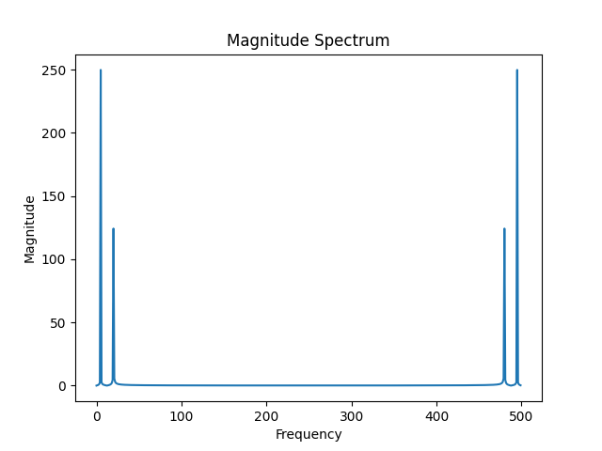
Observation
The given discrete-time signal consists of 8 samples ranging from 1 to 8. FFT is applied to convert the signal from the time domain to the frequency domain. The FFT result contains real and imaginary components. The magnitude spectrum represents the strength of the frequency components, while the phase spectrum represents their phase information. IFFT is then applied to convert the frequency-domain signal back to the time domain. The reconstructed signal is nearly identical to the original signal. This shows that the FFT and IFFT operations are performed successfully. The frequency-domain representation helps in analyzing the characteristics of the signal. The small difference in the reconstructed values, if any, is due to numerical precision. Thus, the transformation between time and frequency domains is verified successfully.

Expected Output
The FFT of the given discrete-time signal will be calculated successfully, producing complex frequency-domain values. The magnitude and phase spectra will be obtained from the FFT result. The IFFT will then reconstruct the original time-domain signal, giving values approximately equal to [1, 2, 3, 4, 5, 6, 7, 8]. The output verifies that the signal can be successfully converted from the time domain to the frequency domain and reconstructed back using IFFT.
Conclusion
FFT was successfully performed on the given discrete-time signal to convert it from the time domain to the frequency domain. The magnitude and phase spectra were obtained successfully. IFFT was then used to convert the frequency-domain signal back to the time domain. The reconstructed signal was approximately the same as the original signal. This confirms that FFT and IFFT operations were performed correctly. The experiment demonstrates the usefulness of FFT for frequency-domain analysis of discrete-time signals.

